**Problem:** Given a data of m examples having n – input features and expected output, train the model from given data using linear regression and then use the model to predict output for a test data.

**Data:** The data is stored in a txt file. It consist of 150 input and output data. Each input data has 4 features.

**Method:**

1. Data Pre-processing: It was necessary to preprocess the data so as to separate input and output data for further use.
2. Initializing Parameters: To implement Linear regression, we have to initialize the parameters.
3. Training the model:

* Calculating expected output using linear regression formula:

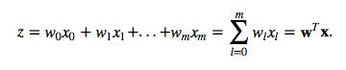

* Since we have to classify the data into 3 classes. Therefore I have applied a softmax function on the expected output.

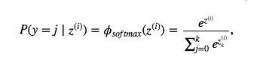

* After using the softmax function to train the model I have calculated the loss(average of all cross entropies over n training examples) occurring and implemented gradient descent on the parameters to minimize my loss.
* Formula’s for calculating loss and cross entropy:

https://sebastianraschka.com/images/faq/softmax_regression/10.png https://sebastianraschka.com/images/faq/softmax_regression/11.png

* Formula for computing gradient descent:

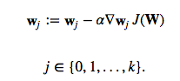 🡪 for each output class j

https://sebastianraschka.com/images/faq/softmax_regression/15.png

* Iterated the above steps to train the model with a learning rate(α) of 0.001

1. After training the model, we have found new parameters. Use these parameters to predict the output for a test point.

**Result:** The model has very good accuracy for prediction.

References: https://sebastianraschka.com/faq/docs/softmax_regression.html